**VISVESVARAYA TECHNOLOGICAL UNIVERSITY**

**“JnanaSangama”, Belgaum -590014, Karnataka.**



**PROJECT WORK-1 REPORT**

**on**

**ONLINE LIBRARY MANAGEMENT SYSYTEM**

***Submitted by***

**AKSHAY DEEP PRASAD (1BM19CS013)**

**ASHUTOSH UPADHYAY (1BM19CS027)**

**DARSHAN NINGTHOUJAM (1BM19CS041)**

**DIVYANSHU JHANWAR (1BM19CS053)**

***Under the Guidance of***

|  |
| --- |
| **POOJA S**  **Assistant Professor, BMSCE** |

***in partial fulfillment for the award of the degree of***

**BACHELOR OF ENGINEERING**

***in***

**COMPUTER SCIENCE AND ENGINEERING**



**B.M.S. COLLEGE OF ENGINEERING**

**(Autonomous Institution under VTU)**

**BENGALURU-560019**

**Sep-2020 to Jan-2021**

**B. M. S. College of Engineering,**

**Bull Temple Road, Bangalore 560019**

(Affiliated To Visvesvaraya Technological University, Belgaum)

**Department of Computer Science and Engineering**



**CERTIFICATE**

This is to certify that the project work entitled “**B.M.S. COLLEGE OF ENGINEERING EVENT PAGE**” carried out by **AKSHAY DEEP PRASAD (1BM19CS013), ASHUTOSH UPADHYAY (1BM19CS027), DARSHAN NINGTHOUJAM (1BM19CS041) AND DIVYANSHU JHANWAR (1BM19CS053)** who are bona-fide students of **B. M. S. College of Engineering.** It is in partial fulfillment for the award of **Bachelor of Engineering in Computer Science and Engineering** of the Visvesvaraya Technological University, Belgaum during the year 2020-2021. The project report has been approved as it satisfies the academic requirements in respect of **Project Work-1 (19CS3PWPW1)** work prescribed for the said degree.

Signature of the Guide                 Signature of the HOD

POOJA S Dr. Umadevi V

Assistant Professor Associate Prof.& Head, Dept. of CSE

BMSCE, Bengaluru BMSCE, Bengaluru

External Viva

Name of the Examiner                                                                                       Signature with date

1._____________________________ ________________________

2. _____________________________ _________________________

**B.M.S. College of EngineerinG**

**DEPARTMENT OF COMPUTER SCIENCE AND ENGINEERING**



***DECALARATION***

We, AKSHAY DEEP PRASAD (1BM19CS013), ASHUTOSH UPADHYAY (1BM19CS027), DARSHAN NINGTHOUJAM (1BM19CS041) and DIVYANSHU JHANWAR (1BM19CS053), students of 3rd Semester, B.E. Department of Computer Science and Engineering, B. M. S. College of Engineering, Bangalore, hereby declare that, this Project Work-1entitled "Online Library Management System" has been carried out by us under the guidance of REKHA G S, Assistant Professor, Department of CSE, B. M. S. College of Engineering, Bangalore during the academic semester Sep-2020-Jan-2021

We also declare that to the best of our knowledge and belief, the development reported here is not from part of any other report by any other students.

Signature

AKSHAY DEEP PRASAD (1BM19CS013)

ASHUTOSH UPADHYAY (1BM19CS027)

DARSHAN NINGTHOUJAM (1BM19CS041)

DIVYASNHU JHANWAR (1BM19CS053)

1. Introduction

Website development for “ONLINE LIBRARY MANAGEMENT SYSTEM”

This online submission system supports Student login and admin login.

**Functionalities for Student login**

i. Students can look for available books in library

ii. Students can register for library

iii. Students can issue and return books.

**Functionalities for Admin login**

i. Admin can see the available books in the library

ii. Admin can add the new books to the library

2. Design Layouts: Screen Shots of Webpages

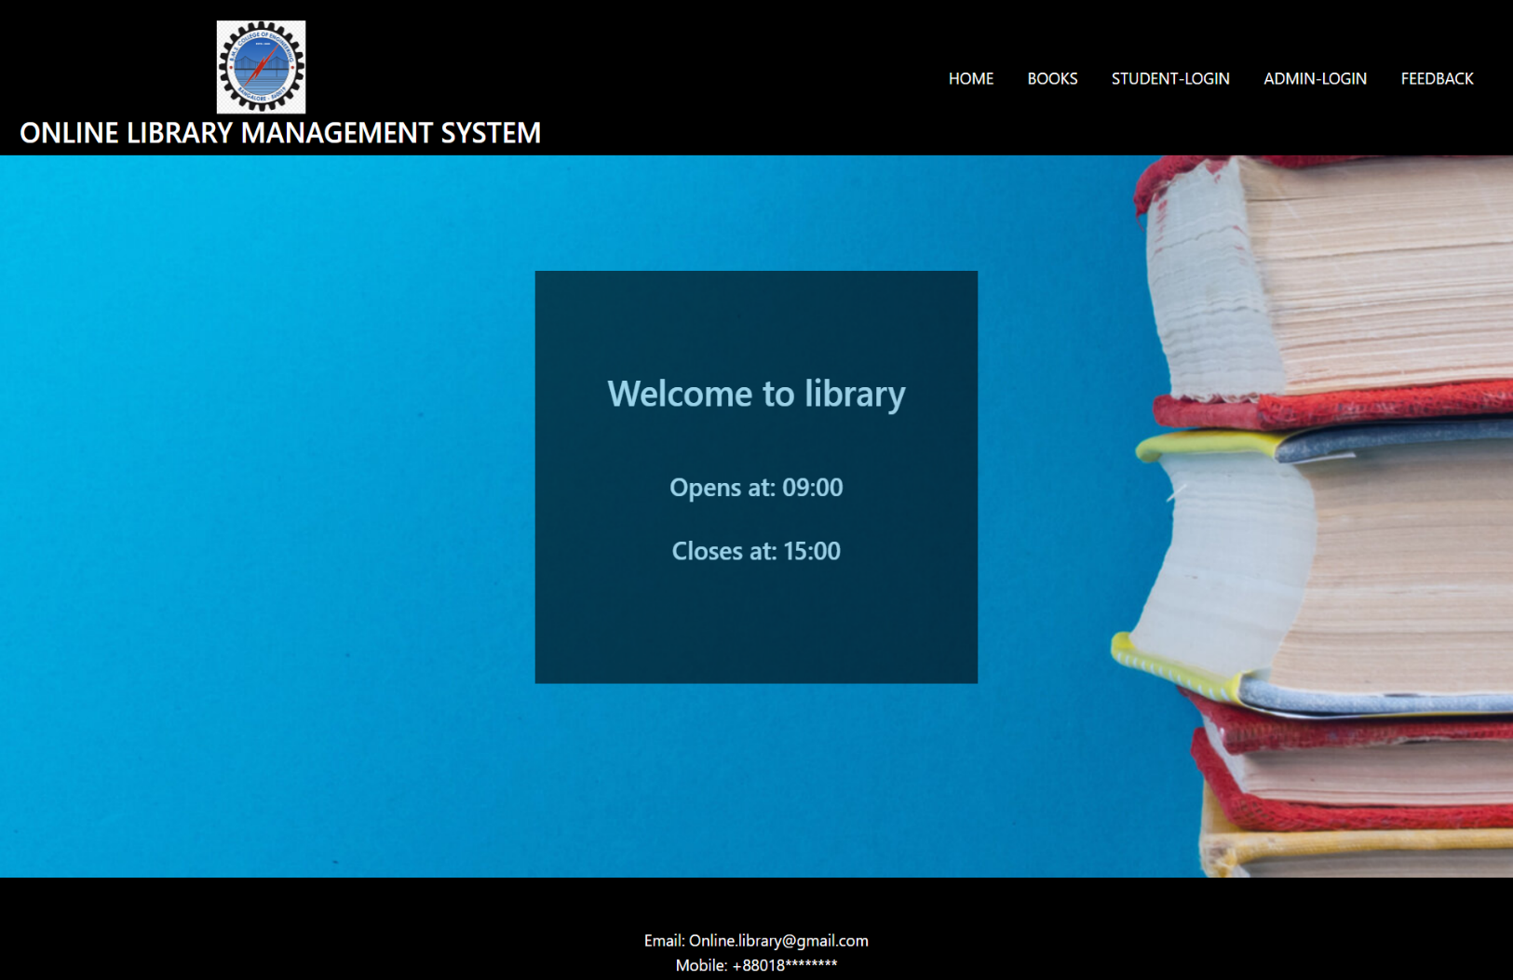2.1: Home webpage

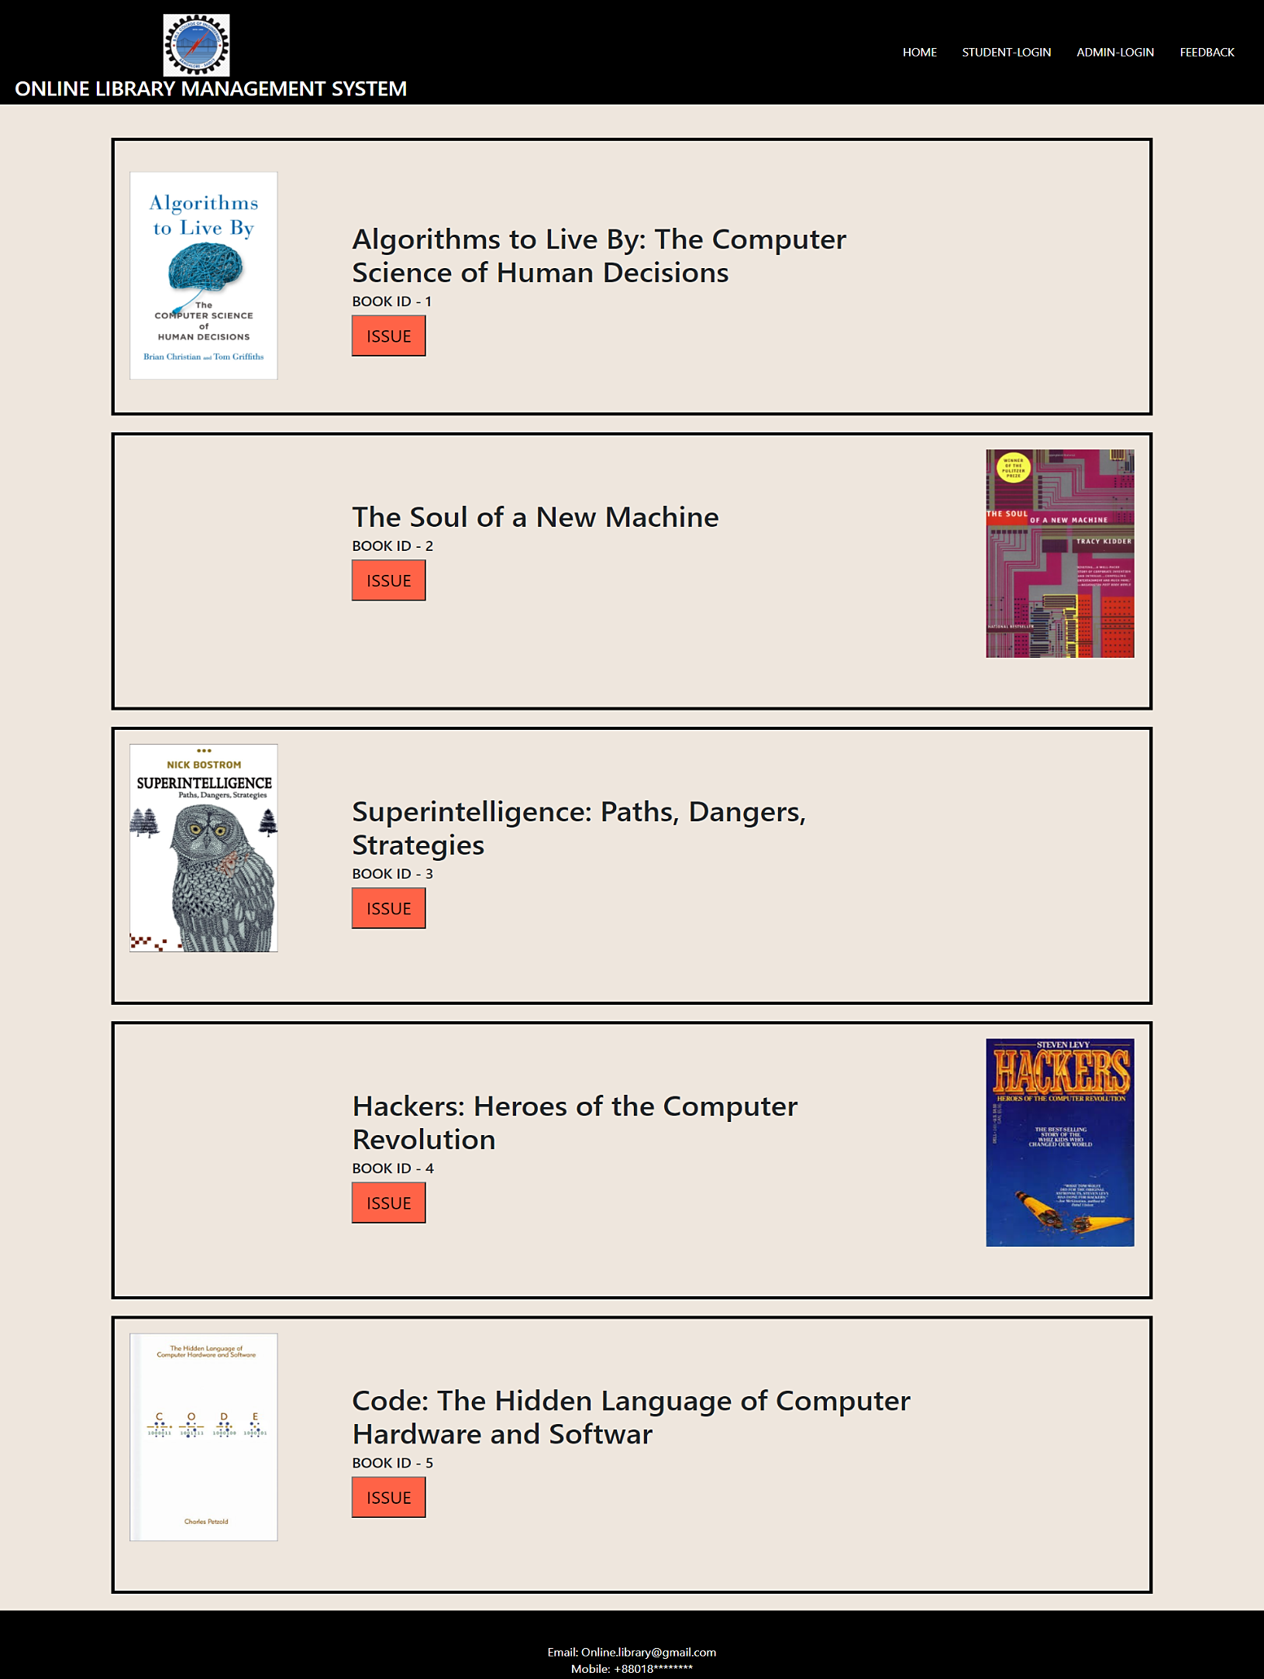2.2: Books Webpage

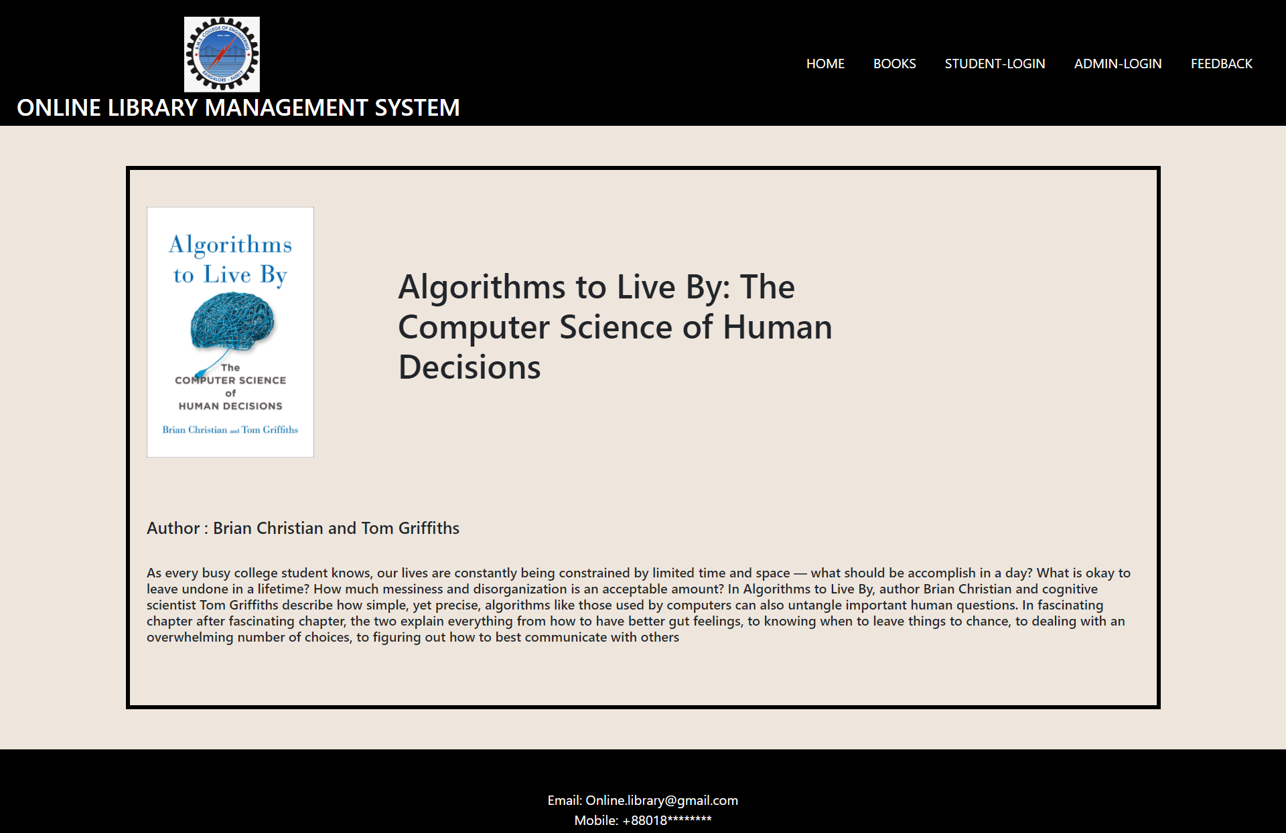2.2: Books-details Webpage

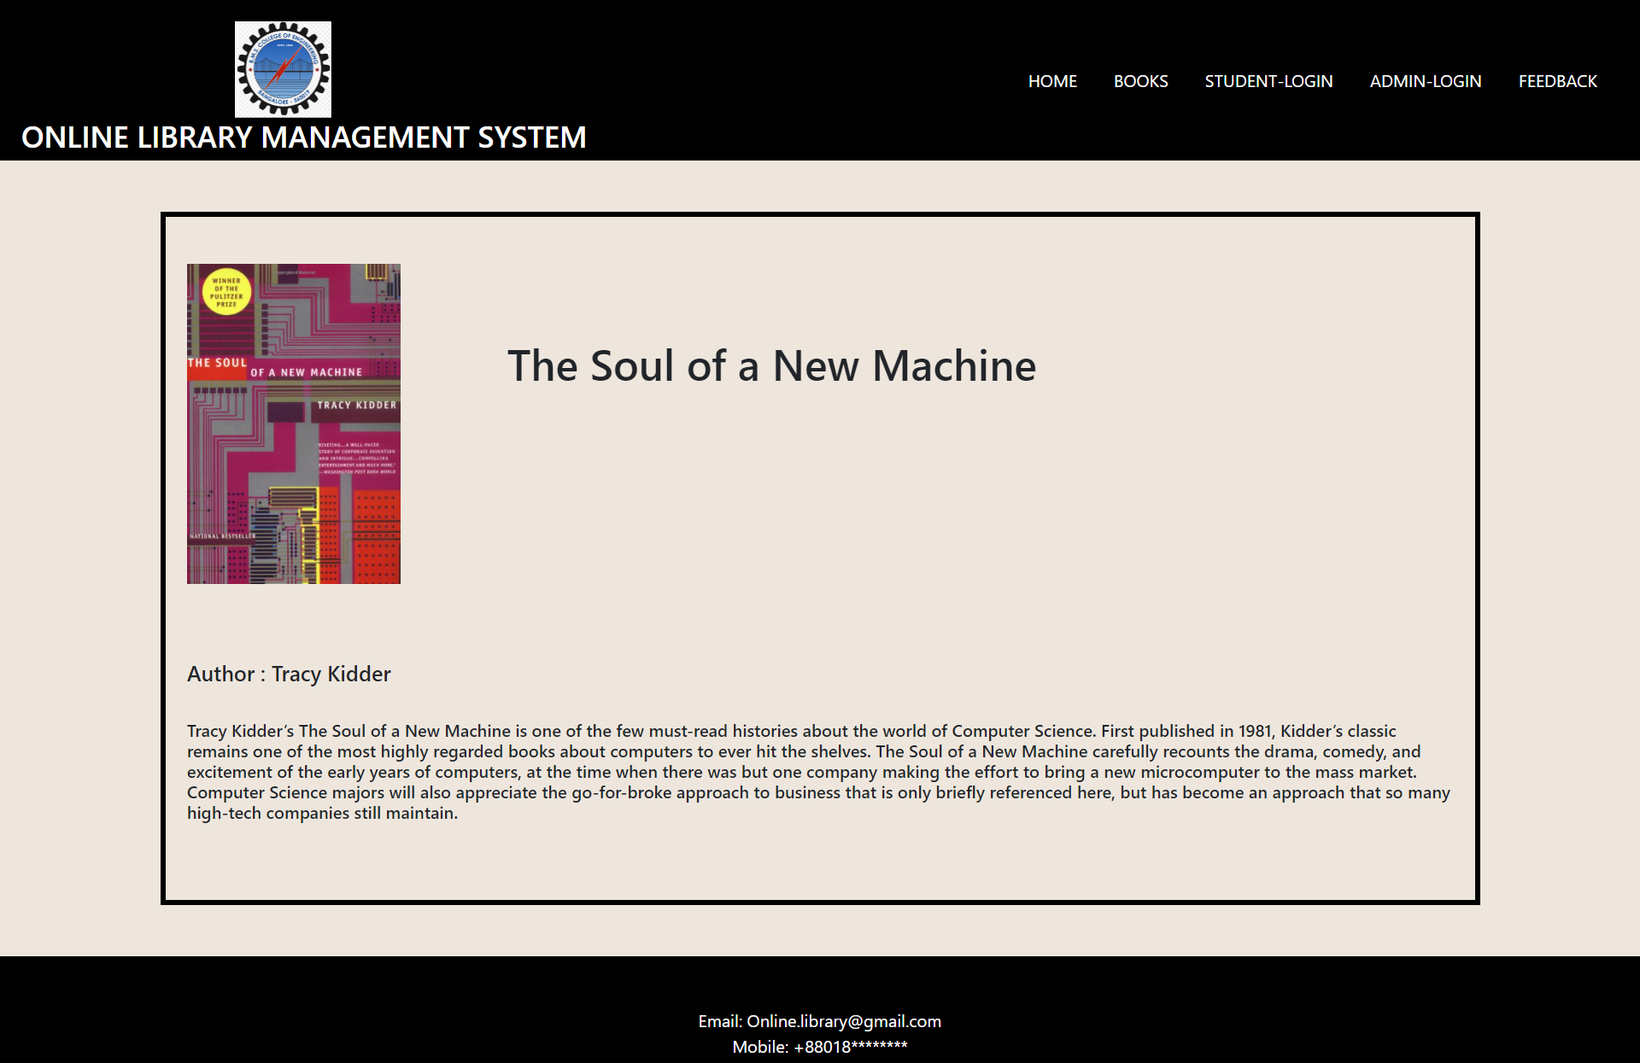2.2: Books-details Webpage

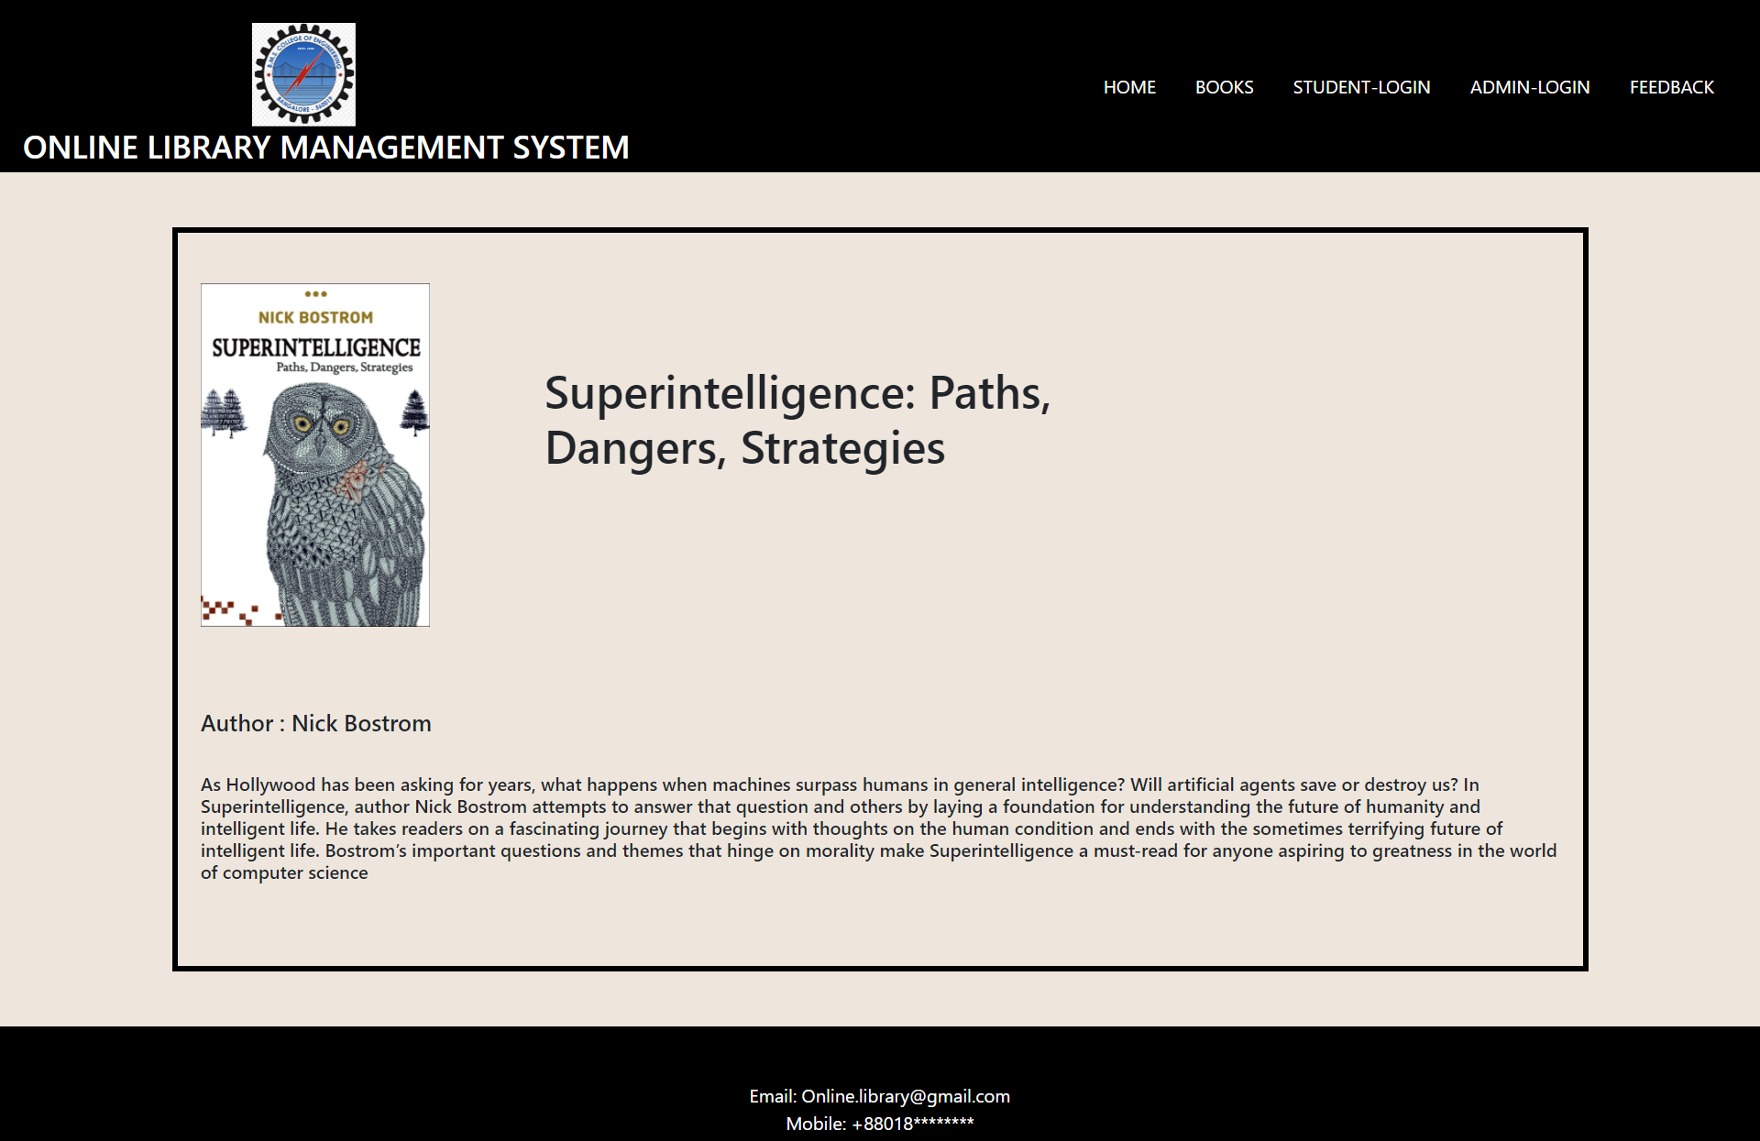2.2: Books-details Webpage

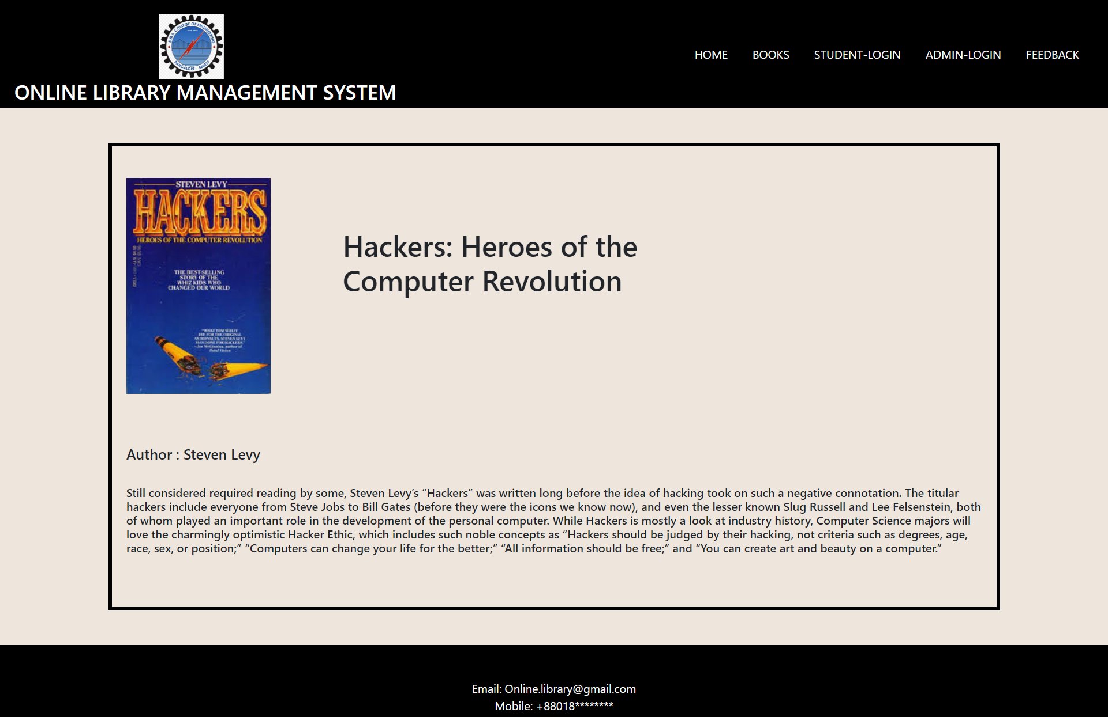2.2: Books-details Webpage

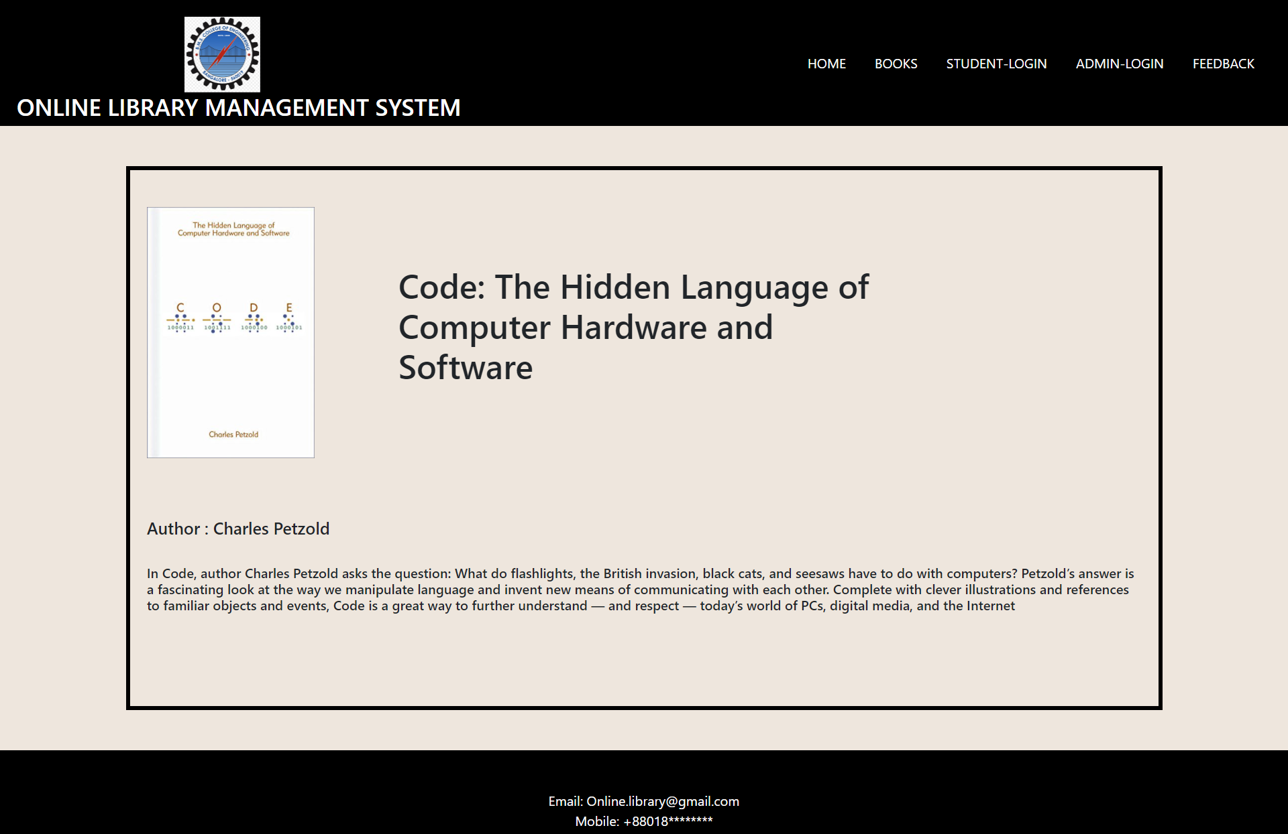**2.2: Books-details Webpage**

2.3: Student Registration Webpage

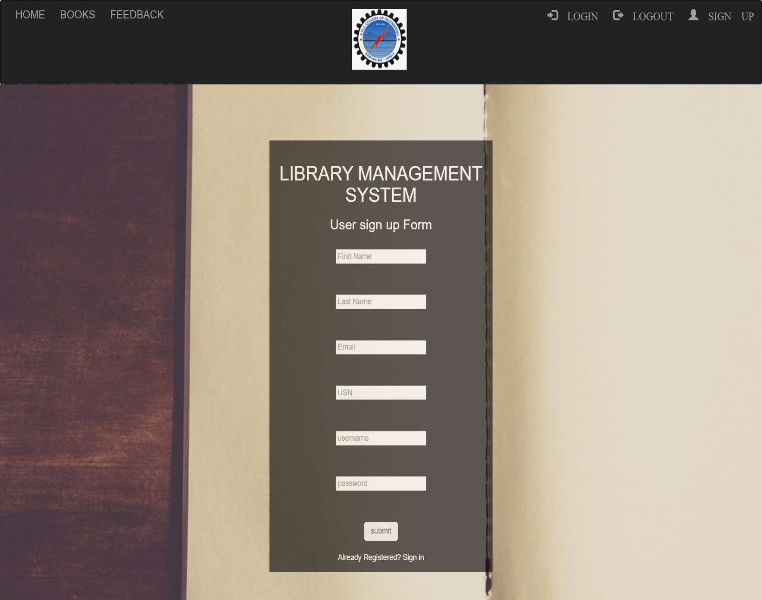

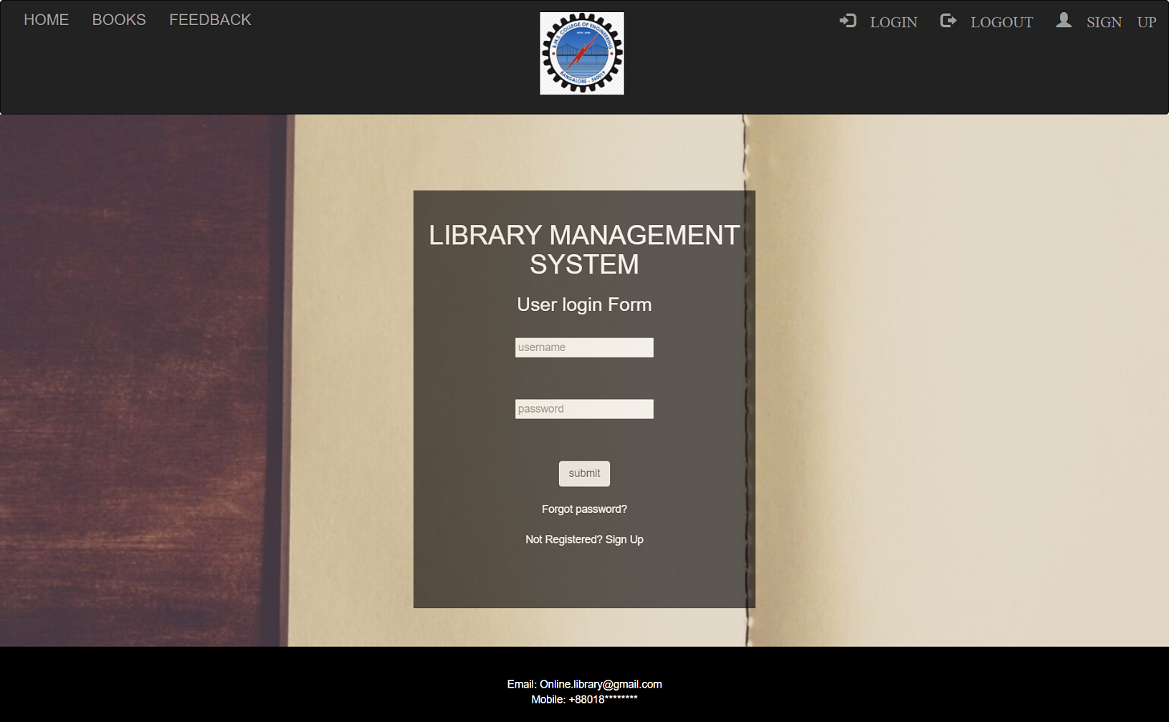2.4.1: Student_login Webpage

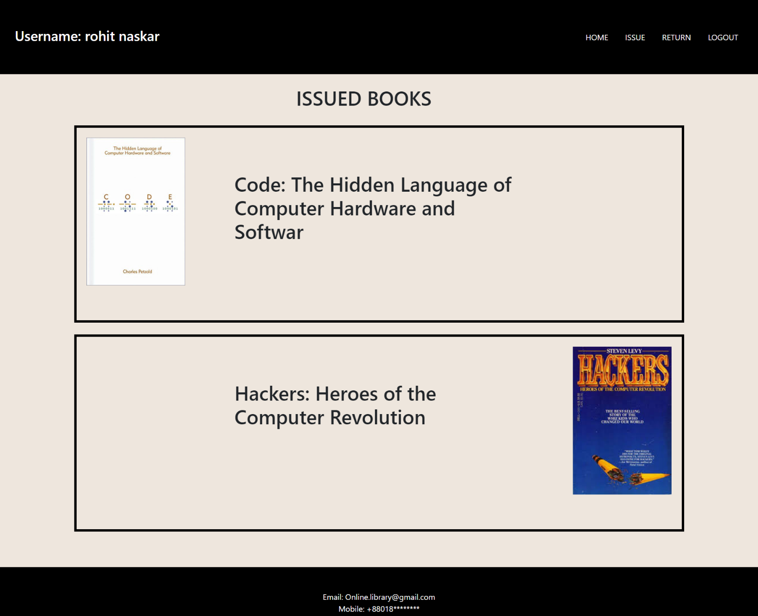2.4.2: Student_login Webpage

\

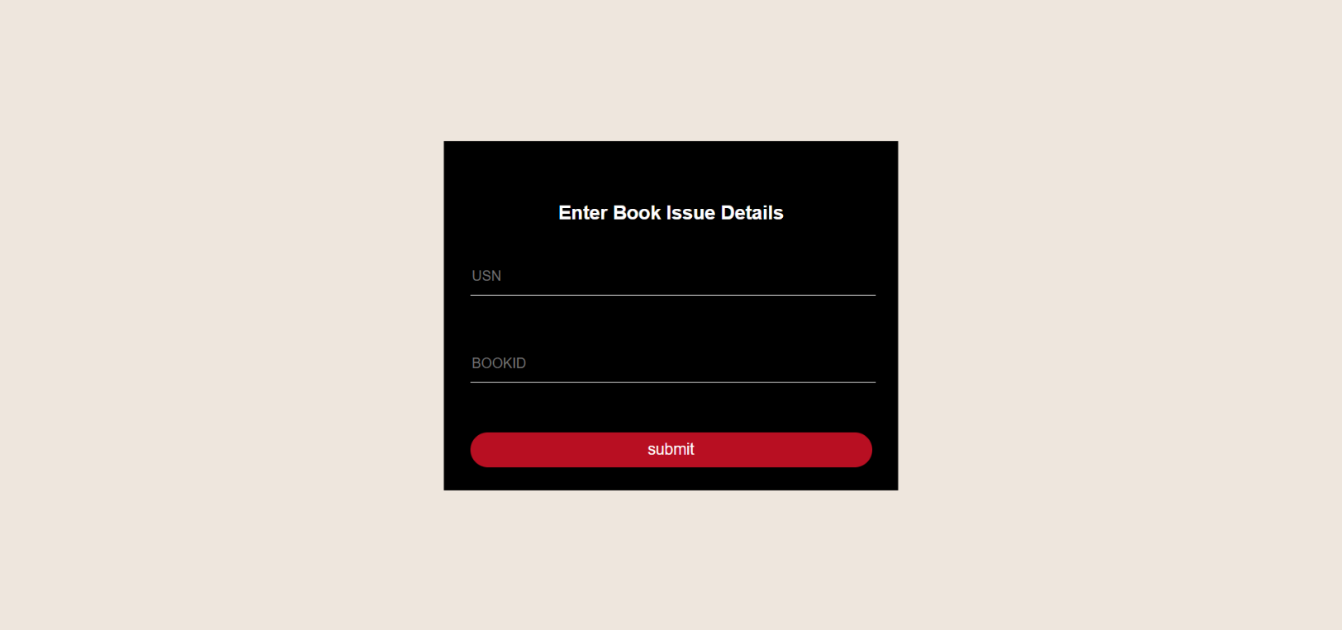2.4.3: Book issue Webpage

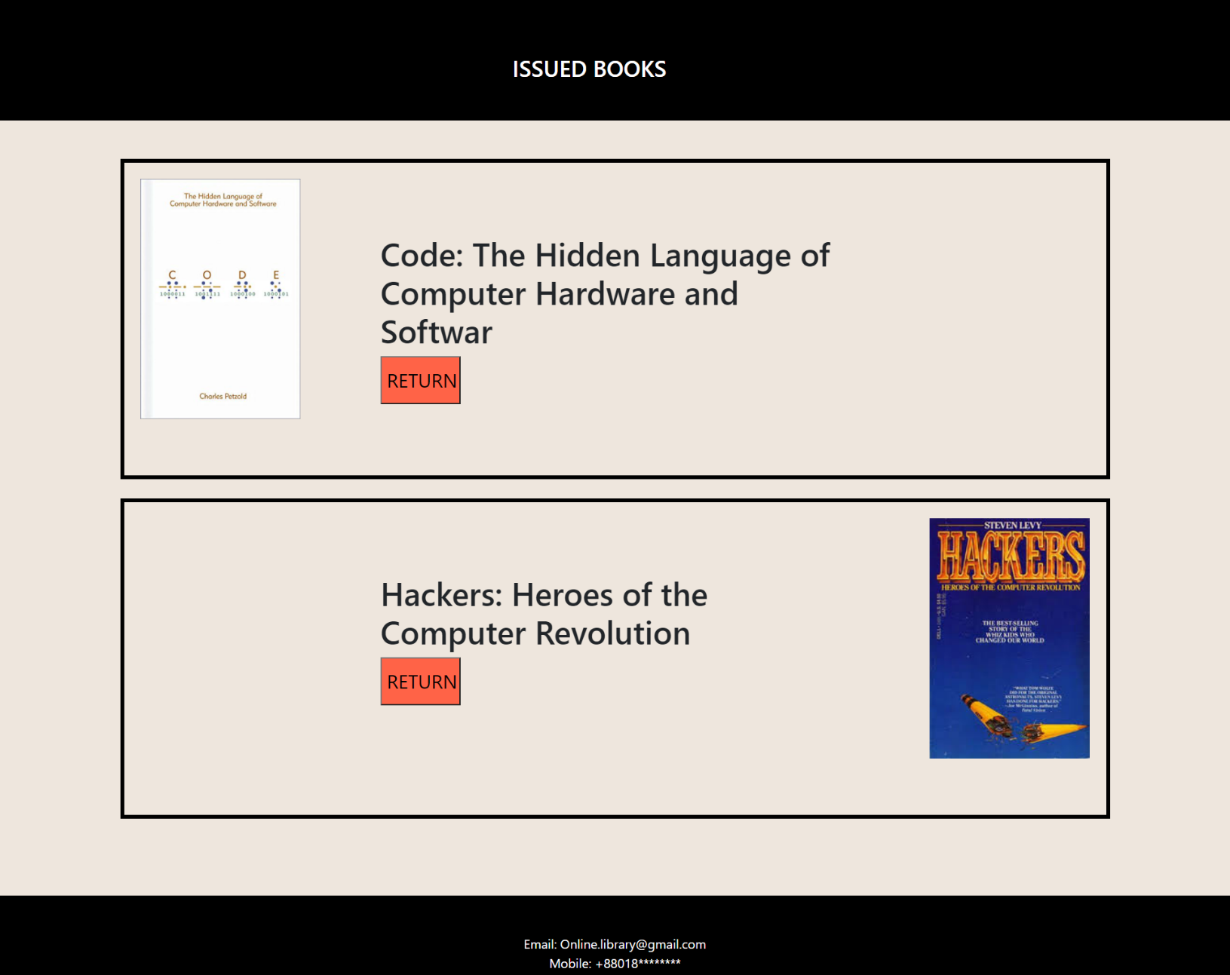2.4.4: Book return Webpage

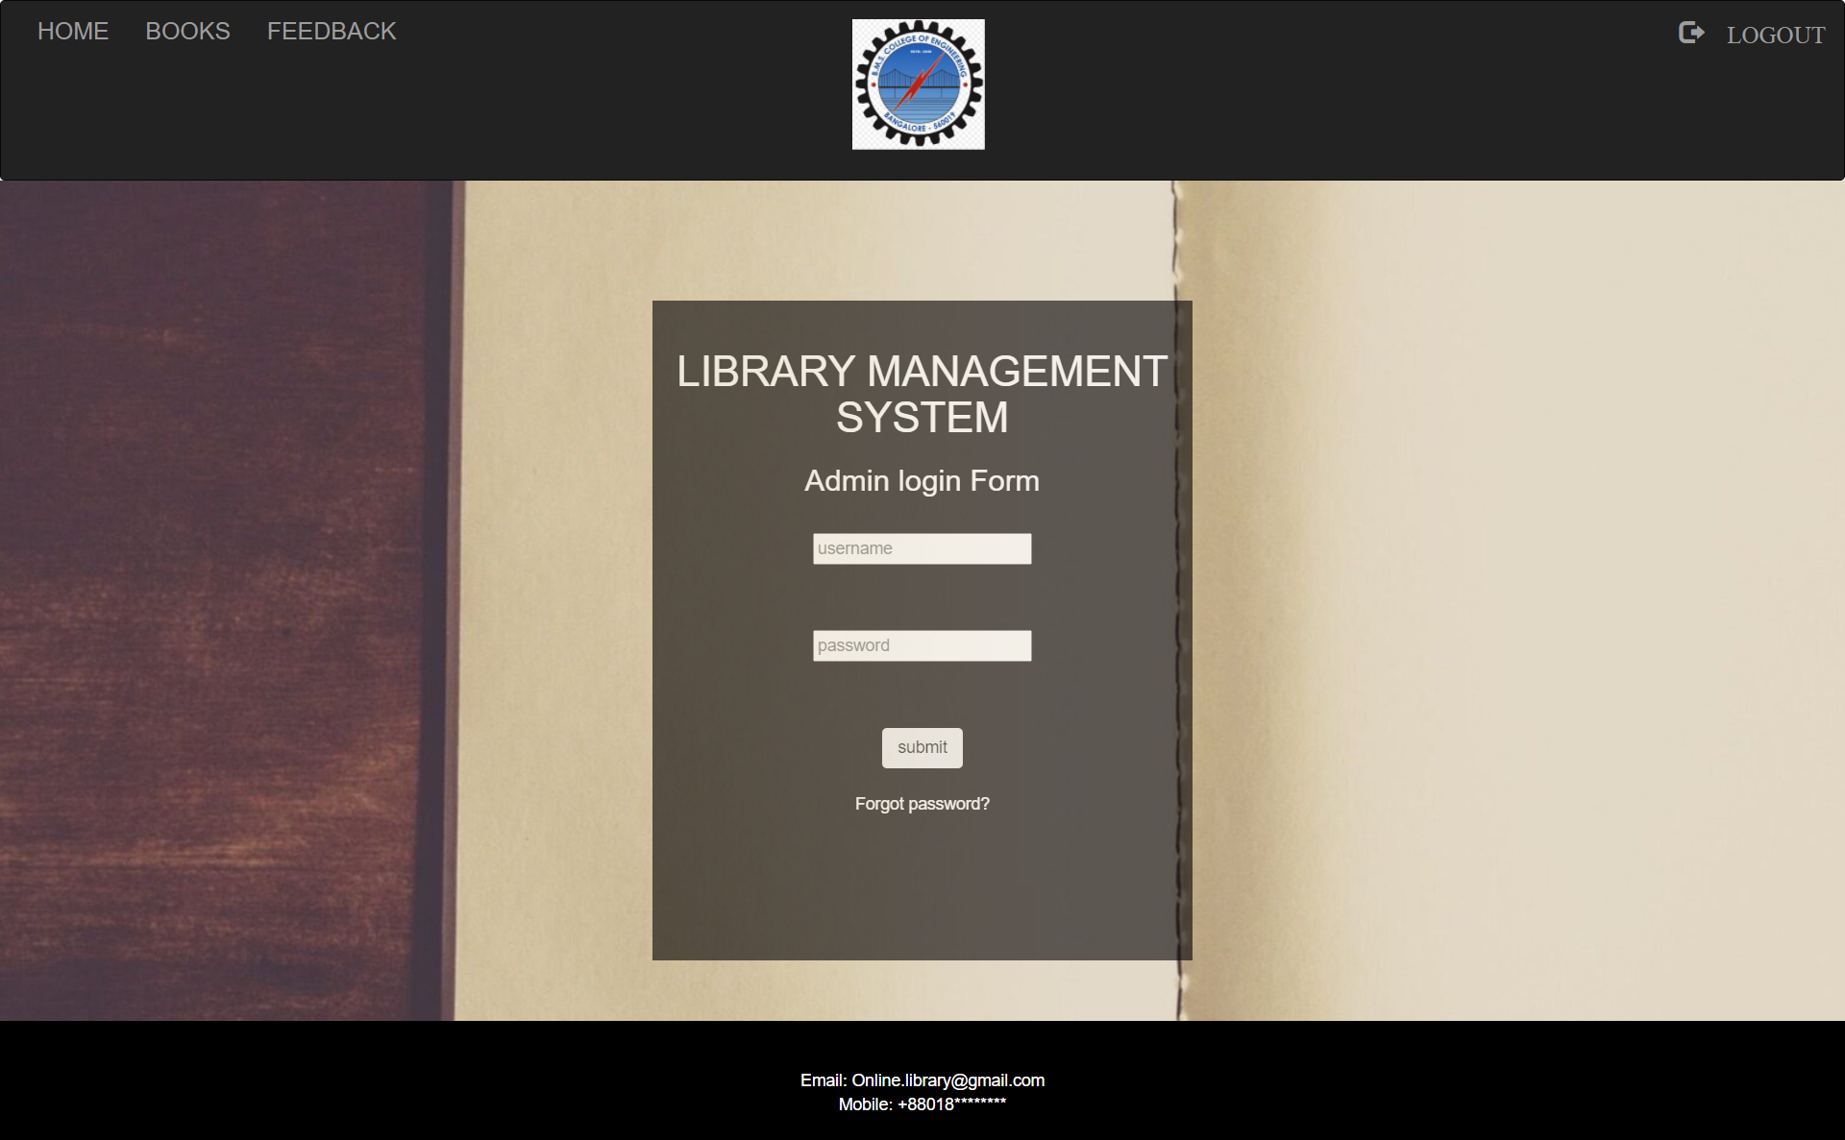2.5.1: Admin Login Webpage

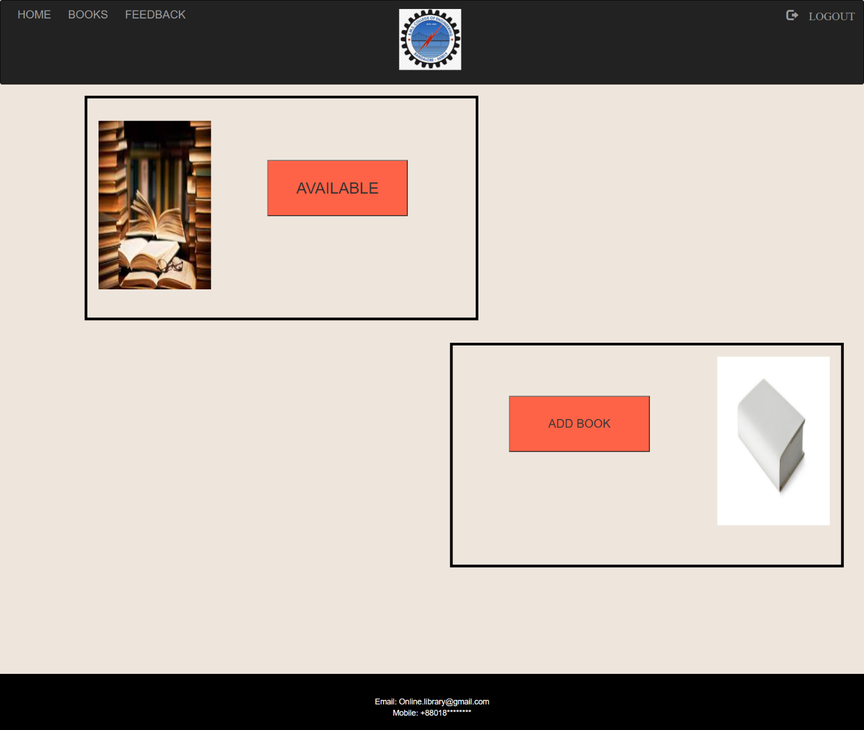2.5.2 : Admin login Webpage

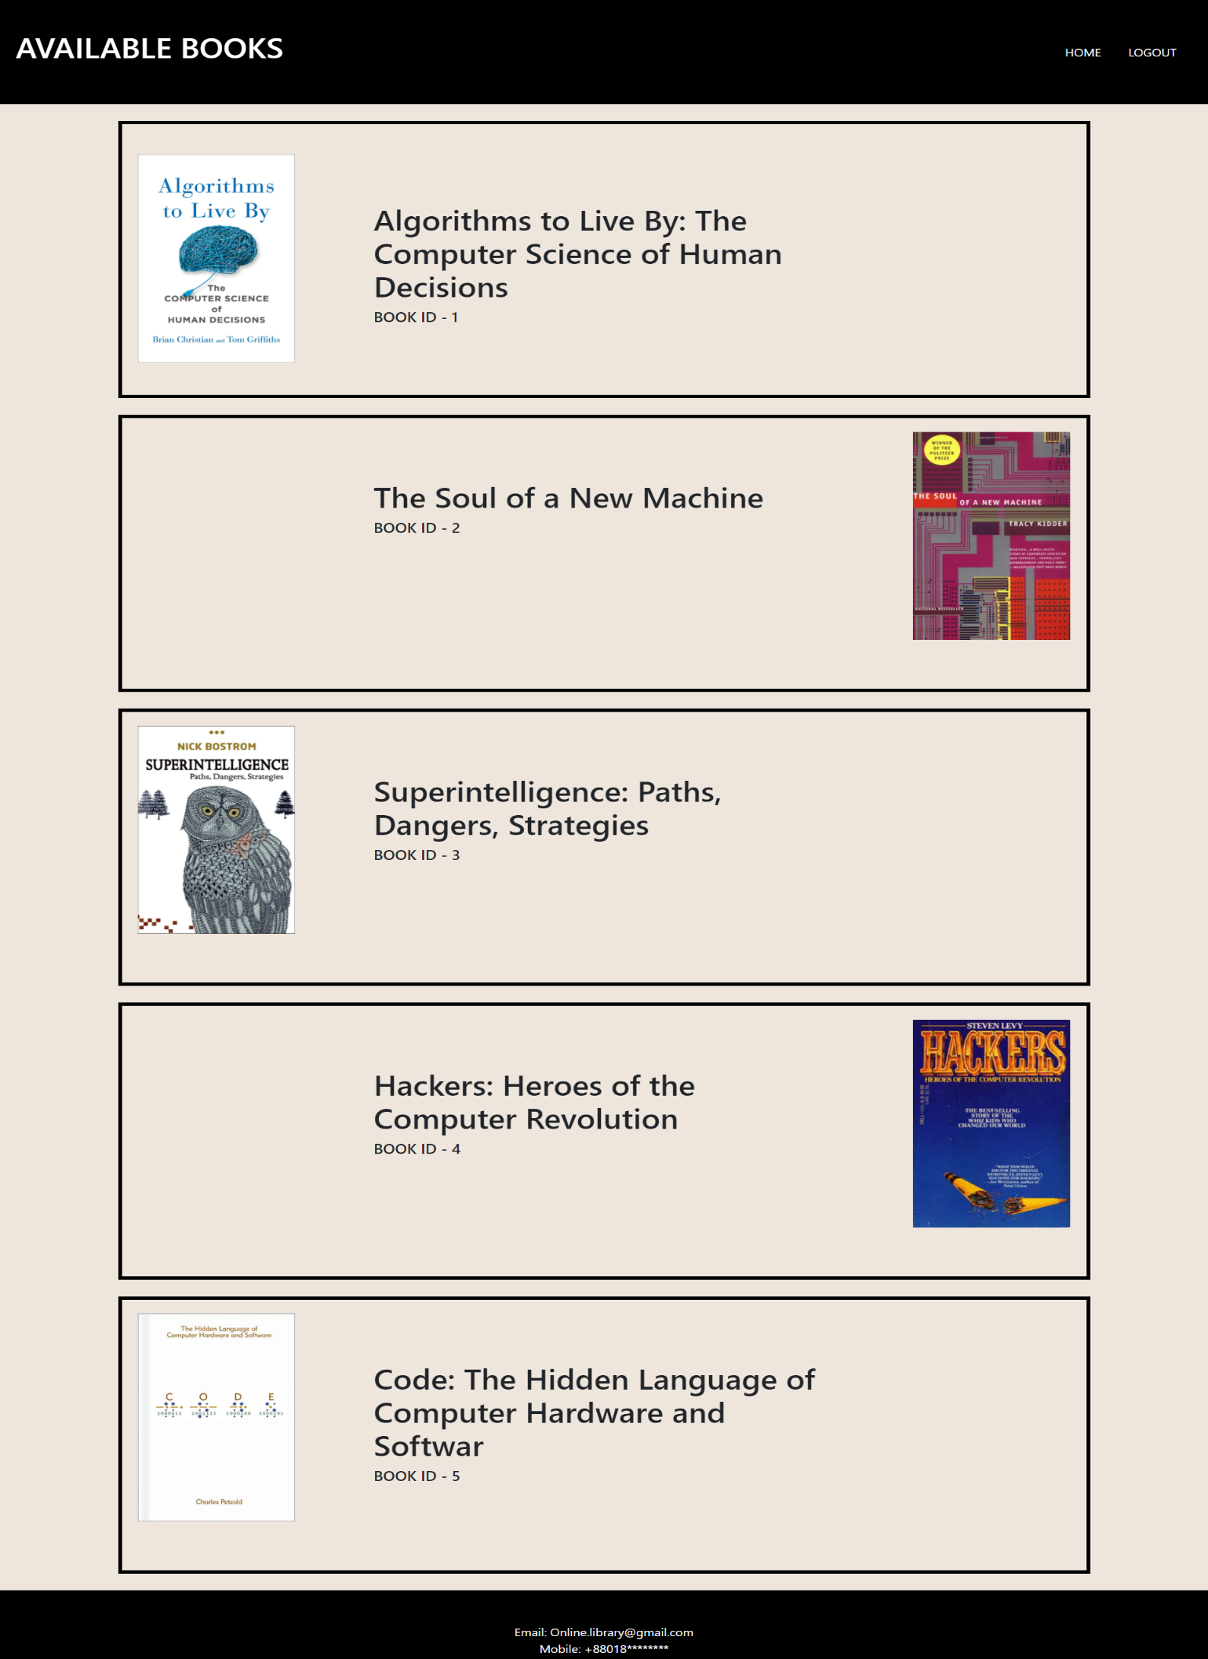2.5.3: Admin login Webpage

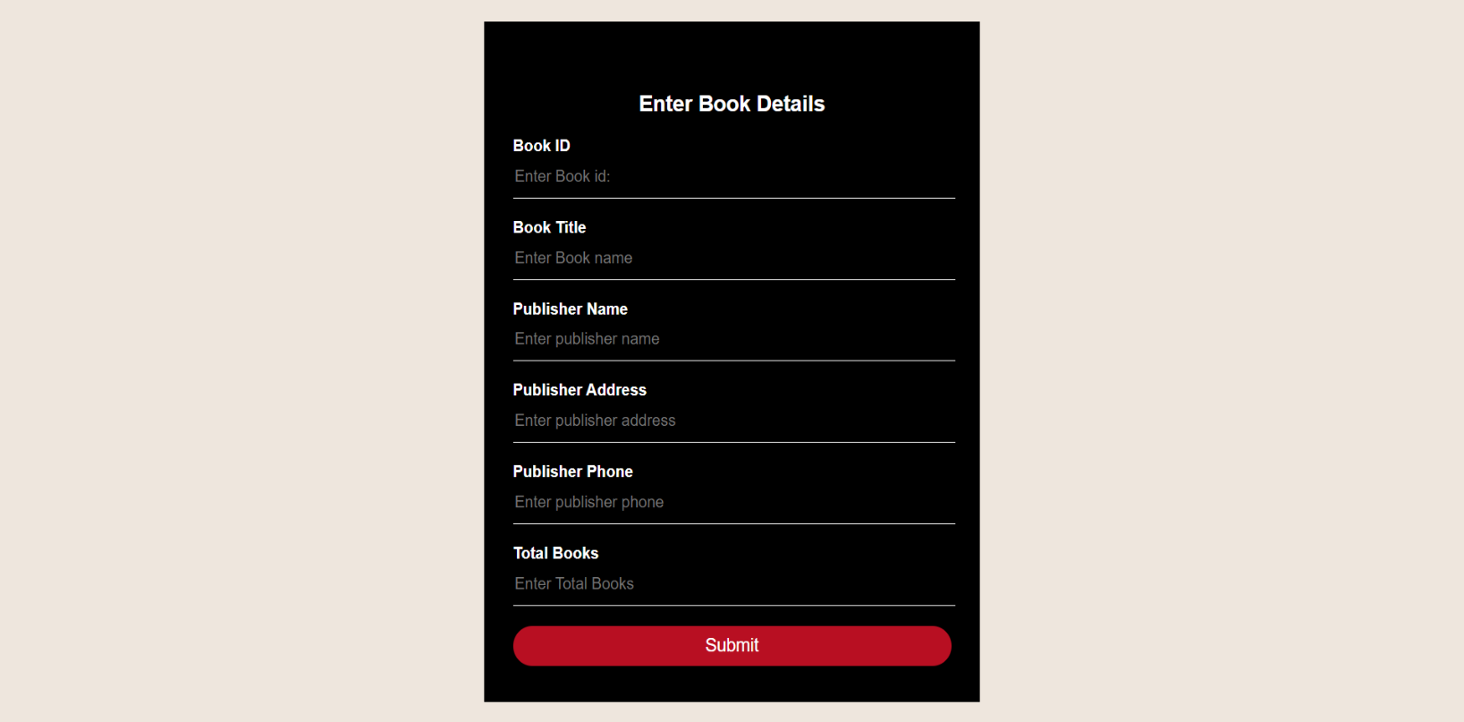2.5.4 : New book addition Webpage

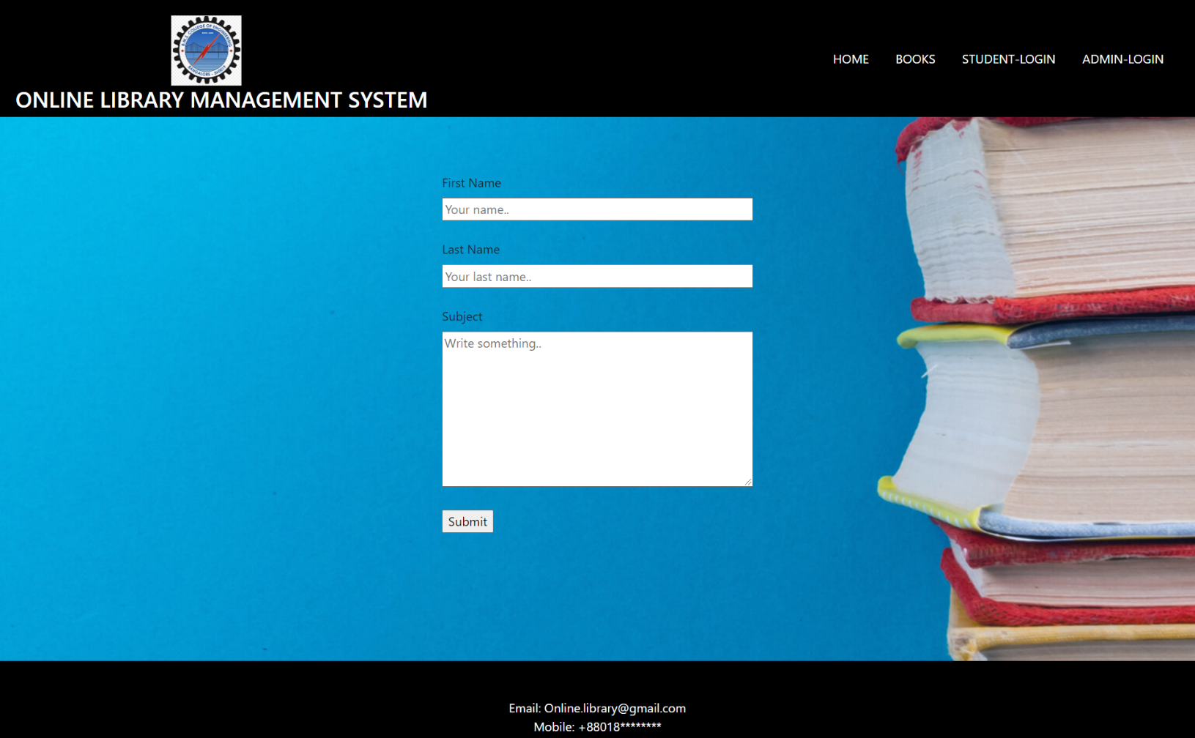2.6 : Feedback Webpage